Solution Architecture
Project Design Phase
Date | 17 July 2026
Team ID | Not provided
Project Name | House Rent Management System (HouseHunt / RentEase)
Maximum Marks | 5 Marks

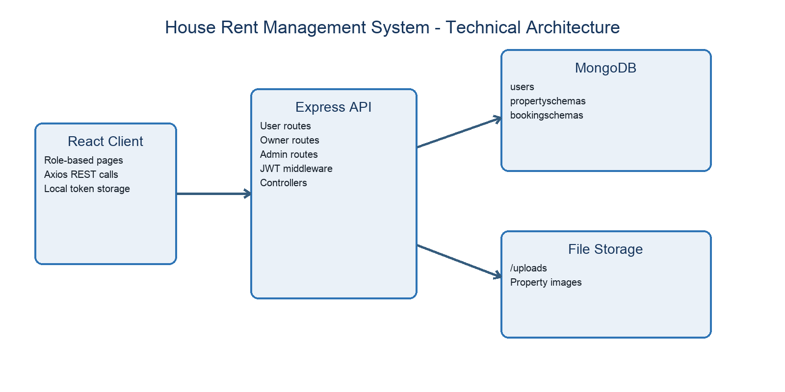
Figure 1. Client-server architecture derived from source code.
Component | Role | Technology
Presentation layer | Public pages and role dashboards | React, Router, MUI, Ant Design, Bootstrap
Client integration | Calls REST endpoints and stores login state | Axios, localStorage
API layer | Routes requests and serves uploaded images | Node.js, Express
Application layer | Registration, login, property, booking, and admin logic | Controllers and JWT middleware
Data layer | Persists users, properties, and bookings | MongoDB, Mongoose
File layer | Stores property images | Multer and /uploads

